Dear Parents and Families,

We are very excited to have your child/children enrolled for the 2023-2024 school year. Everyone is looking forward to an exciting school year. Our enrollment packet will advise you of important dates and information you may need, but if there are any questions, joys or concerns, please feel free to call me at 594-9557 (school)) or via email at jelmer@vpcnaples.org. Please note the possible change in start and end dates per the Collier County Public School Calendar. We will follow their changes if any made by C.C.P.S.

Required Forms:
Some forms in this packet are for you to keep and others are for you to return to school. I have provided you with a checklist of the forms that you must return to minimize the confusion. You will need to provide us with the
Immunization form and a physical form both of which may be obtained from your child’s Florida pediatrician or from the Collier County Health Department. These must be returned to The Learning Center with your tuition payment by April/May 1, 2023. You may mail your forms to the school at 1225 Piper Blvd, Naples Fl., 34110, or drop them off in the church office. Your child will not be able to start school until we have received all the appropriate forms or keep his/her spot if payment and packet is not received by the above date.

Tuition:
PRESCHOOL: The first month’s tuition is due on or before May 1st. Thereafter, tuition is due on the first of each month beginning with August 1st through April 1st.
KINDERGARTEN: The first month’s tuition is due on or before May 1st and June 1st. Thereafter, tuition is due on the first of each month beginning with August 1st through March 1st.
School days in June will be factored into the 10 monthly payments.
Please make your check payable to Vanderbilt Presbyterian Childcare and Learning Center and put your child’s name on the memo line. If you are mailing your tuition, please put to the attention of the preschool in the address field. If you bring the tuition to school, please place it in the drop box located outside the Director’s office. Please do not place any CASH in the drop box.

Open House: AUGUST 8TH – Time -TBA ***** SAVE THE DATE *****

Please feel free to come and meet your child’s teacher during this time. You will also receive and all the necessary information pertinent to your child’s upcoming school year.
Teacher Convention: The Annual Early Childhood Convention will be determined at a later date. We will post the closing time and actual dates as the date is closer.

Please feel free to call me at 594-9557 (school) or via email at jelmer@vpcnaples.org if you have any questions.
Thank you,

Jackie Elmer , Director
Checklist of Forms:

Current Vaccination Form- Blue Form ____
Current Physical Form- Yellow Form ____

Please sign and return with your first month tuition by April 1st/May 1st, 2023

D.C.F. Application for Enrollment #1___
V.P.C.L.C. Enrollment Form #2___
Nutrition Plan/ Discipline Policy #3___
Information and Annual Permission #4___
Auth. for Emergency Treatment-Notarized #5___ Form must be notarized before you turn in to school.
Health and Development Questionnaire #6___
Release /Consent Form #7___
VPCLC Enrollment Contract #8___
Student Directory Listing #9___
Parent Volunteer Form #10___
Volunteer Affidavit #11___
Biting Policy #12___
Covid Release form ______

Please note new DCF food Regulations on page #3.

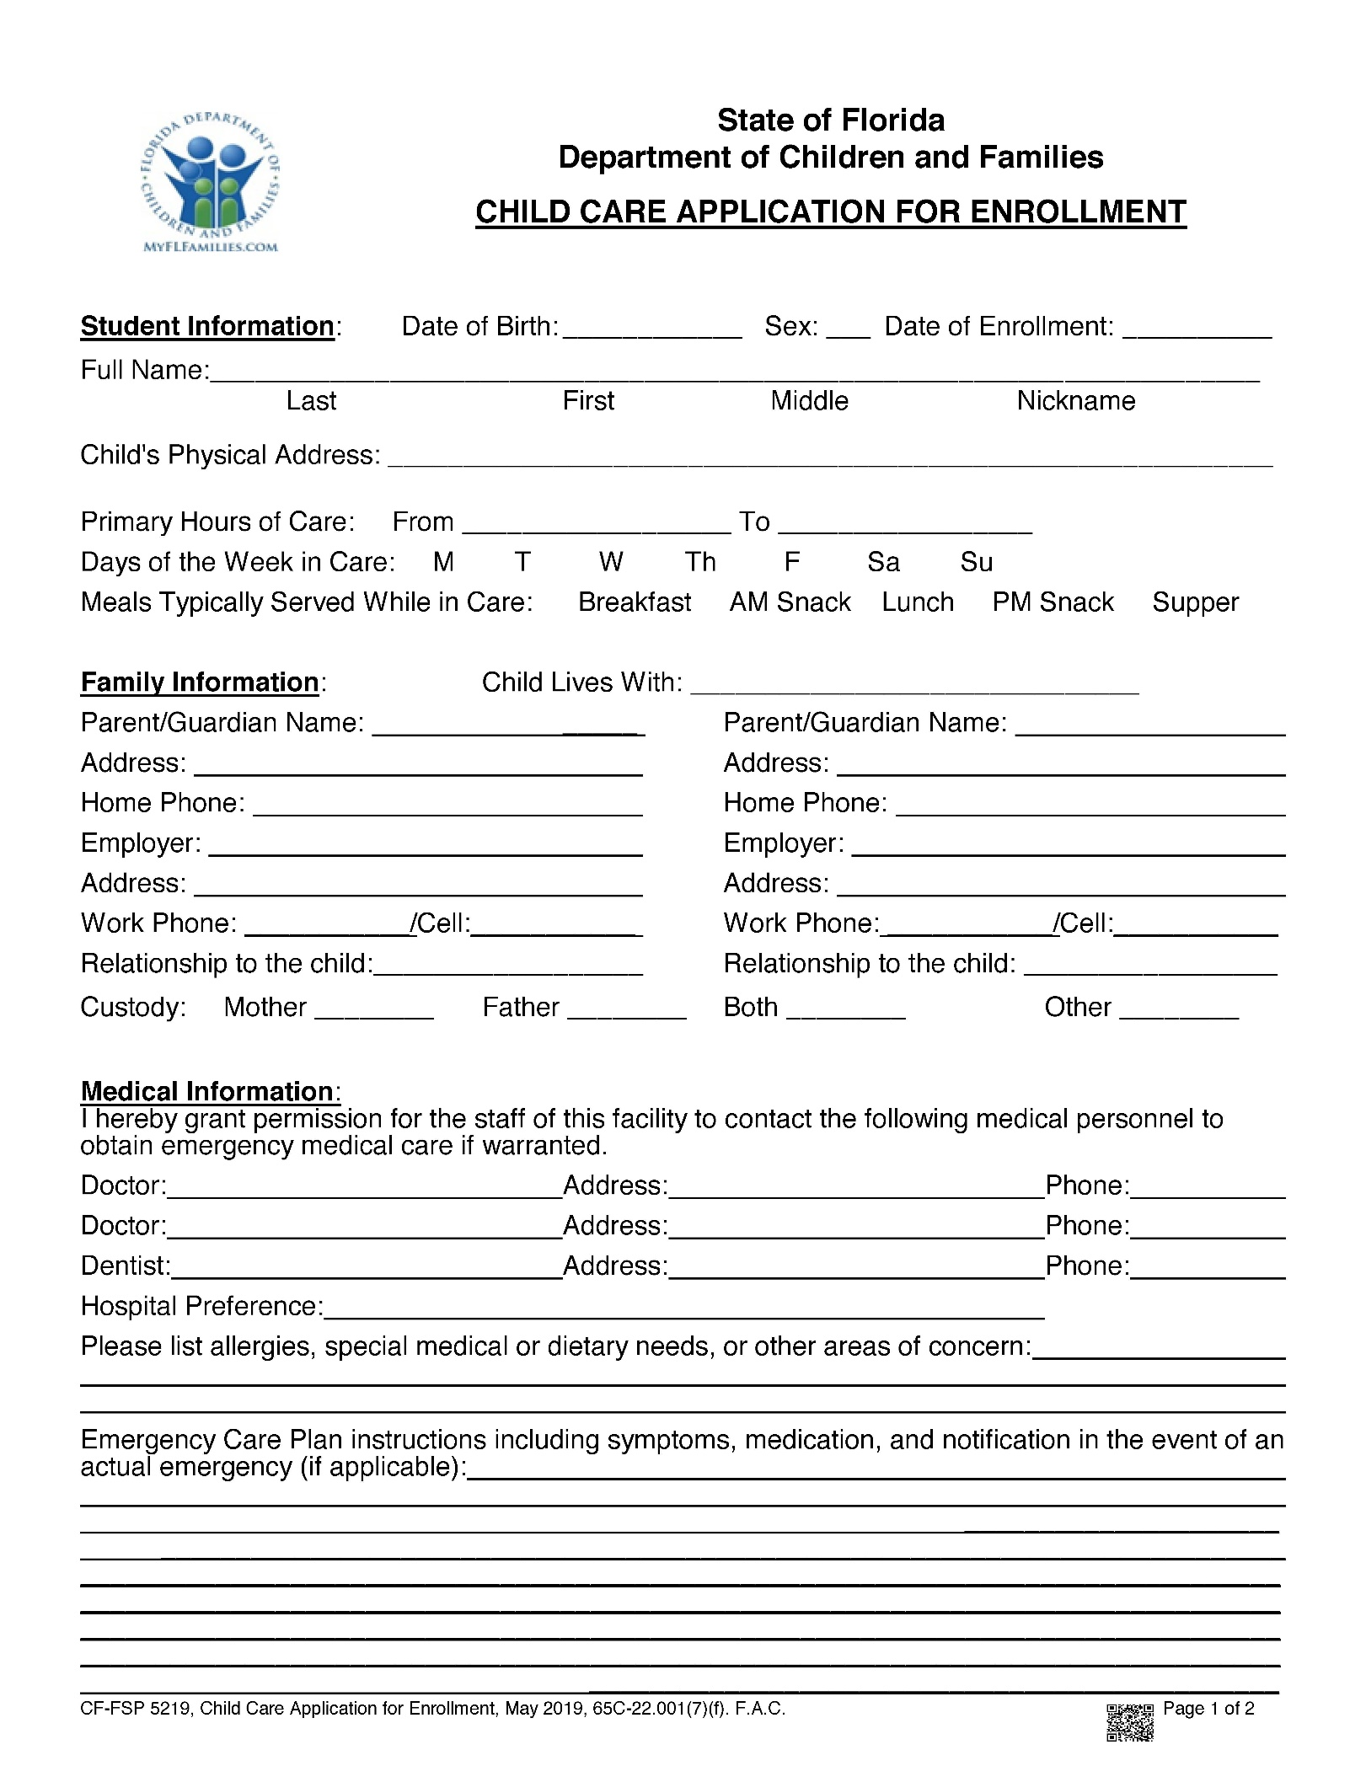
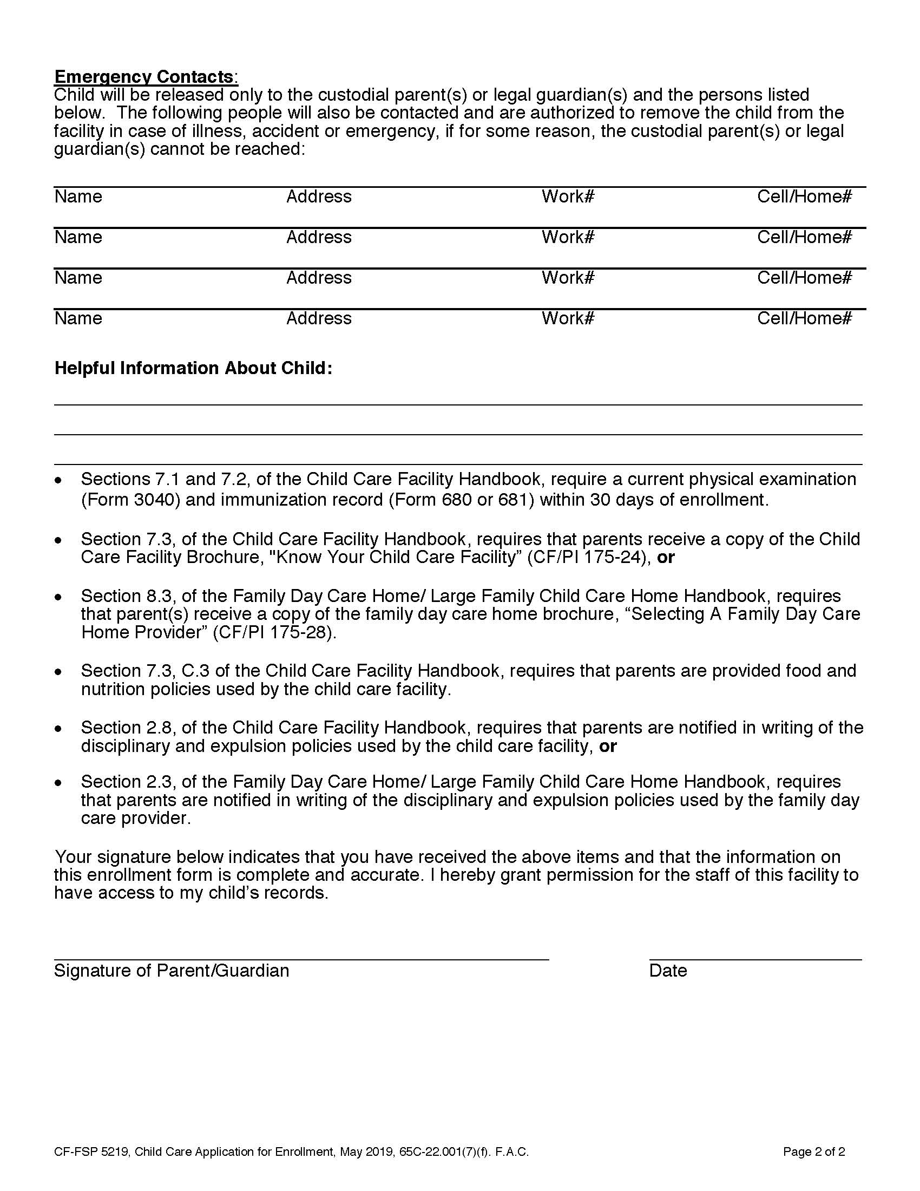
VPCLC CHILD CARE APPLICATION FOR ENROLLMENT #2

STUDENT INFORMATION: Date of Birth___________ Sex ______Child lives with ________________
Full Name: ______________________________________________________________________________________
Last First Middle Nickname
FAMILY INFORMATION

Parent’s name __________________________________Address______________________________________

Home Phone____________________________________Cell_________________________________________

Primary Email Address_______________________________________________________________________ ******************************************************************************************
A non-refundable $200 Registration Fee is required per student, which covers materials, and insurance cost.
******************************************************************************************
 5 DAY 5 YR.KINDERGARTEN - HOURS 8:00 am to12:45 PM TUITION RATE OF $550.00 per month
 5 DAY 4 YR OLD PROGRAM - HOURS 8:30 am to12:30 PM TUITION RATE OF $525.00 per month
 5 DAY 3 YR OLD PROGRAM - HOURS 8:30 am to 12:30 PM TUITION RATE OF $525.00 per month
 3 DAY 3 YR OLD PROGRAM - HOURS 8:30 am to 12:30 PM TUITION RATE OF $425.00 per month
 2 DAY 3 YR OLD PROGRAM - HOURS 8:30 am to 12:30 PM TUITION RATE OF $325.00 per month
 5 DAY 2 YR OLD PROGRAM - HOURS 8:30 am to 12:30 PM TUITION RATE OF $650.00 per month
 3 DAY 2 YR OLD PROGRAM - HOURS 8:30 am to 12:30 PM TUITION RATE OF $450.00 per month
 2 DAY 2 YR OLD PROGRAM - HOURS 8:30 am to 12:30 PM TUITION RATE OF $350.00 per month
 Early Room (E.R.) 7:30am to 8:15am. The E.R tuition rate will be added to your rate as follows:
No Drop off after 8:20. 2 day rate=$25.00. 3 day rate=$35.00. 5 day rate=$55.00 per month.
 Extended Care Program (E.C.P.): HOURS: 1pm until 4:30 pm.
THE E.C.P. TUITION RATE WILL BE ADDED TO YOUR RATE AS FOLLOWS: 2 day rate =$145.00.
3 day rate =$205.00. 5 day rate =$275.00 per month.
I agree to enroll my child in Vanderbilt Presbyterian Childcare and Learning Center beginning August of 2023 through May 2024.
PRESCHOOL: I agree to pay $__________ on May 1, 2023 and then from August 1st, each month on the first of
the month through April 1, 2024, regardless of any absence due to illness, holidays or vacation.
KINDERGARTEN: I agree to pay $__________ May 1, June 1, 2023 and then from August 1st , each month on the first of the month through March 1, 2024 , regardless of any absence due to illness, holidays or vacation.
I understand that a late tuition check received after the 10th of the month will result in a late fee.
I have read and fully understand the terms of this contract. If I remove my child from attending VPCLC prior to June 2024. I understand that I remain liable for the monthly tuition until such time as the vacancy created by my action is filled. Parent Signature_____________________________ Date___________________

Date received_________________Payment number_____________________
Child Day Care Licensing Alternate Nutrition Plan Agreement #3

Name of Facility: Vanderbilt Presbyterian Childcare and Learning Center.
Name of Child:_______________________________________________________
Indicate special Dietary Requirements:__________________________________ Please list on back.

I understand the center does not supply meals or snacks for children in this program. I will be responsible to supply: (Please check all that apply)

A.M. SNACK + DRINK: _______
LUNCH + DRINK: _______
P.M. SNACK + DRINK: _______ (Only for children enrolled in our Extended Care Program)

Please sign below.
Signature of Parent/Guardian ______________________Date___________________
Signature of Director_____________________________Date_____________________

NEW DCF REGULATION: FOODS THAT ARE ASSOCIATED WITH YOUNG CHILDREN’S CHOKING INCIDENT’S MUST NOT BE SERVED TO CHILDREN UNDER 4 YEAR’S OF AGE; SUCH AS, BUT NOT LIMITED TO , WHOLE/ROUND HOT DOGS, POPCORN, CHIPS, PRETZEL NUGGETS, WHOLE GRAPES, NUTS, CHEESE CUBES AND ANY FOOD THAT IS OF SIMILAR SHAPE AND SIZE OF THE TRACHEA/WINDPIPE. Food such as grapes must be cut in half and cheese cubes must be cut into fourths.
NONE OF THE ABOVE FOOD ITEMS WILL BE SERVED BY THE VANDERBILT LEARNING CENTER.

Please sign.
Signature of Parent/Guardian_________________________Date_____________________________

Vanderbilt Presbyterian Childcare and Learning Center Discipline Policy

The purpose of all discipline at Vanderbilt Presbyterian Childcare and Learning Center is to help each child become increasingly self-managing and responsible. Our approach is positive, based on encouragement for appropriate behavior and aimed at helping children develop inner control of their actions. We rely on techniques for diverting attention to constructive pursuits, helping children learn to compromise and arbitrate differences, extending understanding of the reasons for rules and making choices from acceptable alternatives. Short separations from the setting of the problem will sometimes help the child regain his/her self-control (never more than one minute for their age) Parents will be informed if a problem persists. This may require cooperation from home. Dangerous situations will not be tolerated. Parents will be asked to withdraw their child from the preschool if they are not willing to assist in alleviating dangerous situations and seek professional interventions when appropriate.
Physical punishment is NEVER used.
I have read and understand the above policy.

Signature of Parent/Guardian ______________________________Date _________.
# 4
Information and Annual Permission Form

Vanderbilt Childcare and Learning Center
1225 Piper Blvd, Naples, Florida, 34110

Valid from August 1, 2023 to June 1, 2024. PLEASE PRINT LEGIBLY:

Child Information:
Child full/legal name:___________________________________________________________
Preferred name (if different): _______________
Gender: Male __ Female__ DOB: ______________
Home/Mailing address: _________________________________________________________
_________________________________________________________
Child lives with: Both parents ___ Mother ___ Father ___ Other _________________________

Family Information: Please print clearly.
Mother’s Name: ________________________Father’s Name: __________________________
M – e-mail: ___________________________ F – e-mail: _____________________________
M – cell phone: ________________________ F – cell phone: __________________________
M – work phone: _______________________ F – work phone: _________________________
Primary family/home phone: _____________________________________________________

Emergency Contact Information:
In the event a parent cannot be reached at any of the numbers above, please provide two or more emergency contacts. Please make sure that the information is correct and up to date. Please print legibly.

List name, relationship and phone number, and driver license.
1. __________________________________________________________________________

2. __________________________________________________________________________

3.___________________________________________________________________________

4.___________________________________________________________________________

5.___________________________________________________________________________

6.___________________________________________________________________________
RELEASE FOR EMERGENCY CARE #5
AUTHORIZATION FOR EMERGENCY TREATMENT
To Whom It May Concern:
I hereby give my consent to any emergency facility and physician to administer necessary treatment to my child, _______________________ in the event of an emergency at which time I cannot be reached. I give consent to transport by ambulance if situation warrants it. Permission for the Director, Acting Director, or the teacher to take whatever steps may be necessary for medical care of an emergency is hereby given. I understand that the order of actions taken will follow the outline below unless there is a need for immediate action, but will not be limited to these actions:
1. Parent or guardian will be called.
2. Contact person will be called from Parents list.
3. Child’s physician will be called
4. If none of these efforts are successful:
A. Another physician will be called
B. Ambulance will be called
C. The child will be taken to the emergency room of NCH/closest hospital accompanied by a
staff member.
5. In order for the school to assume responsibility for my child, I understand that I must sign the child
in at arrival time and out at departure time.
Family Physician’s Name: __________________________________________________
Phone Number: ___________________________________________________________
Allergies: ________________________________________________________________
Insurance company covering child: ___________________________________________
Policy Number: __________________________________________________________
Expiration Date: __________________________________________________________
Signature of Parent / Guardian_______________________________________________
Printed name of Parent /Guardian_____________________________________________
State of _________________________
County of________________________
On the ______ day of _______________, 20___, before me came___________________
To me know to be the individual descried in and who executed the forgoing instrument and
acknowledged that he executed the same. Type of identification_________________

______________________________________________
Notary Public

_____________________________________________
Print Name

This form must contain only one child’s name, must not be a copy and must be updated annually. PLEASE MAKE SURE THIS FORM IS NOTARIZED BEFORE RETURNING.
Vanderbilt Presbyterian Childcare and Learning Center. #6
Child Health and Development Questionnaire
STUDENT’S NAME_____________________________________________________ SEX ________________
AGE ____________ BIRTH DATE ____/____/_________ WEIGHT ___________________________________
PARENT INFORMATION:
NAME _____________________________________________________________________________________
ADDRESS ______________________________________ PHONE ____________________________________
CITY ____________________________________ STATE _______ ZIP ________________________________
Email Mom____________________________________Dad__________________________________________
Questionnaire:
1. Describe your child's appetite _________________________________________________________________
2. Does your child dislike any foods? ___ If so, what? ________________________________________________
3. What does your child usually eat for breakfast before arriving at the school?__________________________
4. How easily does your child fall asleep? __________________________________________________________
5. What is the usual bedtime? _________ Wake up time? _________
6. What is the usual naptime? _________ Wake up time? _________
7. Is your child completely toilet trained? ___Yes ___No
8. Does your child remain dry all night? ___Yes ___No
9. Are other adults (not family) able to understand the child's speech? ____________________________________
10. Does your child have a regular playmate? ____ Same age ____ Older ____ Younger ____
11. What is your child's favorite toy or activity at home? ______________________________________________
12. Does your child have temper tantrums? ____________How often?____________________________________
13. Does your child bite his/her nails? ___Yes ___No Twist his/her hair? ___Yes ___No
14. If you could describe your child in one word, what would it be? ______________________________________
15. Please list your child's strong points, such as happy, curious, loving, etc. _______________________________
16. Is there anything else, medical or otherwise that we need to know about your child? _______________________________________________________________________________________________________________________________________________________________________________________________________________________________________________________________________________________
__________________________________________________________________________________________________________________________________________________________________________________________
17. Would like more information on Vanderbilt Presbyterian Church? ___Yes ____No.
18. Is this your child’s first preschool experience? ____Yes ____No
Anything else you would like to share about your child_____________________________________________________________________________________________________________________________________________________________________________________________________________________________________________________________________________________________________________________________________________________________________________________________________________________________

RELEASE FORM # 7

I have received, read and understand the Florida Dept. of Children and Families brochure entitled “Know Your Child Care Center”. Initials ______.

I have read and understand the Parent Handbook. Initials ____.

I hereby consent to having my child photographed, recorded on audiotape, or videotaped by the Vanderbilt Presbyterian Childcare and Learning Center for the sole purpose of pre-school activities or church business. The end product WILL NOT be made for public information and will only be used by the Learning Center Staff, students and families. Initials ____.

I have read and understand the Influenza Virus Brochure. Initials _______.

I understand that during parties or activities, my child might be eating homemade food.

______My child DOES NOT have a food allergy or dietary restrictions. He or she MAY PARTICIPATE.
______My child DOES have food allergy or dietary restrictions. He or she MAY NOT PARTICIPATE.
I will provide a snack for my child on these days. The food allergies are__________________________________________________________________Initials _______

I understand that during parties or activities my child will be touching house pets.
I DO WANT my child to participate _______
I DO NOT WANT my child to participate _______
Initials _______
I understand that VPCLC will have a WATER DAY and
I DO WANT my child to participate _______
I DO NOT WANT my child to participate _______
Initials _______
I understand the Biting policy. Initials____________.
I have read and understand the Potty trained policy. Initials_______
I have read and understand the Covid Policy. Initials__________

Child’s Name____________________________________________________________

Signature of Parent/Guardian_______________________________________________

Parent’s name (Please Print) ________________________________________________

Date: ______________.
Vanderbilt Presbyterian Childcare and Learning Center #8a
1225 Piper Blvd.
Naples, Florida 34110
239-594-9557
Revised December 2022
Enrollment Contract

School Calendar: 2023-2024 CONTRACT
Students enrolled under the school contract will follow the Collier County Public School calendar and any changes made by the C.C.P.S. throughout the school year. The first day of school is August 10, 2023 and the last day of school will be May 30, 2024.
*Please note that VPCLC will also be closed on a Thursday/ Friday TBA (teachers will be attending the Annual Early Childhood Convention in Jacksonville). T.B.D... There will be NO AFTER SCHOOL CARE THE DAY BEFORE CONVENTION. As soon as the date is confirmed we will let you know.
School Day
The Learning Center opens at 7:30am for those children enrolled in the Extended Room Program (E.R.).Occasional early drop off is available with permission from the Director. You do need to sign up to drop off early as there is limited space available. (See added fees for early morning drop off) All other children should arrive AFTER 8:00/8:30 am and go directly to their classroom. Pre-school classroom hours are from 8:30am-12:30pm and the Kindergarten classroom hours are 8:00 am-12.45 pm. This is the academic portion of the day involving curriculum taught by qualified teachers. Students will be in their classrooms, in classes of 9-14, participating in educational age appropriate practices designed to prepare them for the next grade level. Kindergarten will be preparing the students for first grade. These activities enhance pre-reading and math skills, fine and gross motor development, cognitive thinking skills, and socialization. Students also participate in all school activities planned for the day, including music class, chapel, or visits from guest speakers. A portion of the morning pre-school class is devoted to outside play on the playground. Parents should send a prepared snack and lunch that does not require heating or refrigeration. Lunch schedule will be determined by each teacher and posted. Students will have lunch in their classrooms with their teacher. The normal pre-school day will end at 12:30pm.and students must be picked up by 12:45pm.in car line. Kindergarten pick-up time will be at 12:45 pm, in carline.
A late fee will be charged if students are not picked-up on time.

Early room is from (7:30-8:20 am). A separate fee is charged for Early room Care, please see page #2 for prices.
Extended Care Program: (Afternoon Childcare 12:30-4:30p.m.)
The Extended Care Program is designed to serve working families by providing quality childcare that keeps children actively learning during the day. These activities may include art projects, indoor and outdoor games, or storytelling. It is all designed to nurture and develop students overall well-being. Parents of children participating in this program will be required to enter into a contractual agreement for the entire school year. Due to classroom and staffing limitations, space for this program is limited and is strongly suggested that parents sign up their children as soon as possible. Applicants will be accepted on a first come-first serve basis: if needed, VPCLC will open up a waiting list for this program and spaces will be filled as they become available.

#8B

Students attending this program will have a rest time from 1:00 pm to 2:00 pm daily. They will not be required to sleep, but will be required to be quiet and restful on a cot. All children will need a “child size” tote or backpack to carry personal belongings for naptime. The class Tote bags supplied by the teachers are for lunch/snack box and parent/school communication exchange ONLY!
(NO Electronic devices or games will be allowed)
Children will need an all in one rest mat. These items will be taken home and laundered on weekends. Afternoon snack provided by the parent is served at 2:15pm. A daily planned activity will take place as well as outside play. The last hour of the day is spent free playing. Parents are welcome to pick their children up anytime between 2:30pm and 4:30pm. You and your child must exit the building prior to 4:30pm per VPLC school clock. The monthly fee schedule is: 5 days= $275.00, 3 days= $205.00, 2 days= $145.00 and is in addition to your monthly tuition rate. Please note calendar dates when there is no P.M. Childcare.

TUITION PRICES ARE AS FOLLOWS AND ARE BASED ON STUDENT CONTRACT DAYS, NOT CALENDAR DAYS - Please check all that apply. Please note early room and afternoon care is approved by the Director.

 (M-F) Five day Kindergarten from 8:00am-1:00 pm - $550.00 per month, 10 equal pays.

 (M-F) Five day Pre-K 4 from 8:30am-12:30 pm - $525.00 per month, 10 equal pays.

 (M-F) Five day Pre-K 3 from 8:30am-12:30 pm - $525.00 per month, 10 equal pays.

 (M-F) Five day 2 year old program from 8:30am-12:30pm for $650.00 per month, 10 equal pays.

 (MWF) Three day PRE-K3 from 8:30am-12:30 pm for $425.00 per month, 10 equal pays.

 (MWF) Three day 2 year old program 8:30am-12:30pm for $450.00 per month, 10 equal pays.

 (T, TH) Two day PRE-K3 from 8:30am-12:30 pm for $325.00 per month, 10 equal pays.

 (T, TH) Two day 2 year old program from 8:30am-12:30pm for $350.00 per month, 10 equal pays.
 Afternoon room, 12:30/1:00 - 5:00 pm (Check all that apply)

5 ER’S = $55.00 per month 5 day PM’S= $275.00 per month
3 ER’S = $35.00 per month 3 day PM’S= $205.00 per month
2 ER’S = $25.00 per month 2 day PM’S= $145.00 per month

 I agree to pay $_____________ on the first day of each month according to schedule, regardless of any absences due to illness, holidays or vacation. I understand that a tuition check received after the tenth of the month will be considered late and will result in a late fee charged to my account.
 I have read and fully understand the terms of this contract. If I remove my child from attending Vanderbilt
Presbyterian Childcare and Learning Center prior to the dates listed above, I understand that I remain liable for the monthly tuition until such time as the vacancy created by my action is filled.

#8C

 I have read all the terms and conditions and agree to enroll my child in Vanderbilt Presbyterian Childcare and Learning Centers SCHOOL YEAR ENROLLMENT CONTRACT August 1, 2023 through the month of May 1, 2024. My child will attend on all regularly scheduled school days according to the Collier County Public School Calendar, excluding all listed non-school days.

 I fully understand the potty trained policy. All children entering the preschool three and four year old classes MUST be completely potty trained and must be able to use the rest rooms independently. Reoccurring accidents may result in the child not being able to attend school per D.C.F.

 I fully understand the child must have age-appropriate immunizations prior to enrollment, or religious exemption form on file. Due to newly enrolled students or students with the religious exemption form, some children in care may not have current immunizations. New records must be turned in to the VLC office PRIOR to the expiration date.

________________________________________________
Parent Signature Date
#9
Student Directory Listing

Please fill out legibly all information as you would like it to appear in the student directory that is given to all students at the beginning of the school year. If you would not like your information included in the directory, please check the appropriate box, and sign and return this form with your enrollment packet. Please sign your name in the appropriate space at the bottom. This directory is for social communication and is not intended for business use. Please initial here __________.
Thank you for your cooperation.
PLEASE PRINT

Student’s name _______________________________________________________________________________

Mother’s name _______________________________________________________________________________

Mother’s address _____________________________________________________________________________

Mother’s home phone# ____________________________Cell Phone #__________________________________

Mother’s email _______________________________________________________________________________

Father’s name ________________________________________________________________________________

Father’s address _______________________________________________________________________________

Father’s home phone _____________________________Cell Phone #____________________________________

Father’s email _________________________________________________________________________________

_____ please include my information in the student directory.

_____ I do not wish for my information to be included in the directory.

Mother’s signature ____________________________________ Date___________

_____ please include my information in the student directory.

_____ I do not wish for my information to be included in the directory.

Father’s signature ____________________________________ Date___________

Parent Volunteer Form #10

Dear Parents,
Over the course of the school year there are many special events that enrich your child's school experience. Many of these events require parental participation to ensure that they run smoothly. We need your help. We would like you to take a moment to complete the following time and talent survey so that we will know which events you would most like to help with during the year. None of them requires a big time commitment. In addition, if you have any special talents (e.g., balloon animals, juggling, musical instrument, drawing, foreign language, being a fireman) or have something special that you would like to share through demonstration with the kids (e.g., a pet, piece of machinery, craft project) during an hour or two during the year, please let us know.

PLEASE PRINT

Your name________________________________________________________________________
Your child's name__________________________________________________________________
Your telephone number____________________________________________________________
Your email address_________________________________________________________________
Which of the following would you be most interested in assisting with? Please check all that apply.
Serving on the preschool parent committee (one hour each month) ________________________
Storytelling or reading to the children _______________________________________________
Room parent_______________________________________________________________________
Teacher Appreciation Week (in early May) __________________________________________
Helping with Dr. Seuss Week (first week in March)____________________________________
Other______________________________________________________________________________
Do you have any special talents or things that you would like to share with the kids or do you know someone with special talents who might be interested in sharing them with our kids? If so, what would you like to share? Please list below.
_____________________________________________________________________________________________________________________________________________________________________________________________________________________________________________________________________________________________________________________________________________________________________________________________________________________
VOLUNTEER AFFIDAVIT #11

I attest my name is _________________________________________________ and
(print volunteer/foster grandparent name)
serve in the child care program known as ____________________ _____________.
(print name of child care program)
I serve as a (check one)

􀀀 Volunteer – As a volunteer, I do not receive any form of payment or compensation such as money, free or reduced child care, or any other type of compensation for my time. I also understand that as a volunteer, I must be under the constant supervision a trained and screened staff person and may not be left alone or in charge of any group of children. If I volunteer 10 hours or more per month, or receive some form of
compensation I understand that I must submit background screening information in
accordance with section 402.3055, Florida Statutes, and complete the state mandated
training requirements.

􀀀 Foster Grandparent – As a foster grandparent, I adhere to all of the Foster Grand-parent Program Guidelines pursuant to Title 45, Public Welfare, Code of Federal Regulations, section 2552.75. I also understand I must be under the constant supervision of a trained and screened staff person and may not be left alone or in charge of any group of children and complete training as outlined in the rule 65C-22.003(1)(m) or rule 65C-20.009(1)(a), Florida Administrative Code
I attest that I have read the foregoing, and the facts alleged are true and correct.

_____________________________________________ ______________________
Volunteer/Foster Grandparent Signature Date

To Be Completed by the Owner/Operator/Director
I attest my name is _________________________________________________, and I
(print owner/operator/director name)
am the owner/operator/director of the child care program identified above. The above
(circle one)
individual serves, under the above definition, as a volunteer/foster grandparent in this child care program.
I attest that I have read the foregoing, and the facts alleged are true and correct.
_____________________________________________ _____________________ Owner /Operator /Director Signature Date

CF-FSP 5217, Volunteer Affidavit, August 2010, 65C-20.009(3)(e), 65C-22.006(3)(c)4. and 65C-22.008(3)(u)4.,d., F.A.C.
BITING POLICY #12
Biting, unfortunately, is not unexpected behavior for toddlers. Some children and many toddlers communicate through this behavior. However, biting can be harmful to other children and to staff.
If a biting incident occurs, state regulations require that the parent of the child biting and the parent of the child who was bitten be contacted. Names of the children are not shared with either parents.
VPCLC strongly disapproves of biting. The staff’s job is to keep the children safe and help a child that bites learn different, more appropriate behavior.
However, after consulting preschool experts and manuals, VPCLC has developed the following policy to be used if and when biting occurs in any of our rooms:
-Staff will remove biter from the situation, the wound of the bitten child will be assessed and cleansed with soap and water and covered with a bandage, if needed.
-An incident report form is filled out and parents of both children will be contacted.
-The parents of the biter will be asked to come and pick-up the child for the remainder of the day.
If the biting continues and the child inflicts 2 more bites, whether the skin is broken or bruised or the bite leaves a significant mark, a parent conference will be held with the Director.
If it is deemed in the best interest of the child, center and the other children, termination of the child from the center enrollment may occur.

I read the VPCLC Biting Policy and agree with its terms.
I will contact the director immediately with any questions or concerns.

Please sign, date and return to the office. Thank you for your cooperation

_____________________________________ Parent signature and date

